WEB TECHNOLOGY WITH UI UX
ASSIGNMENT 1 – TASK 1
NAME: Keval Panchasara ROLLNO: 51
CLASS: 4CE C BRANCH: CE

Step 1 - Click on New button to create a new repository

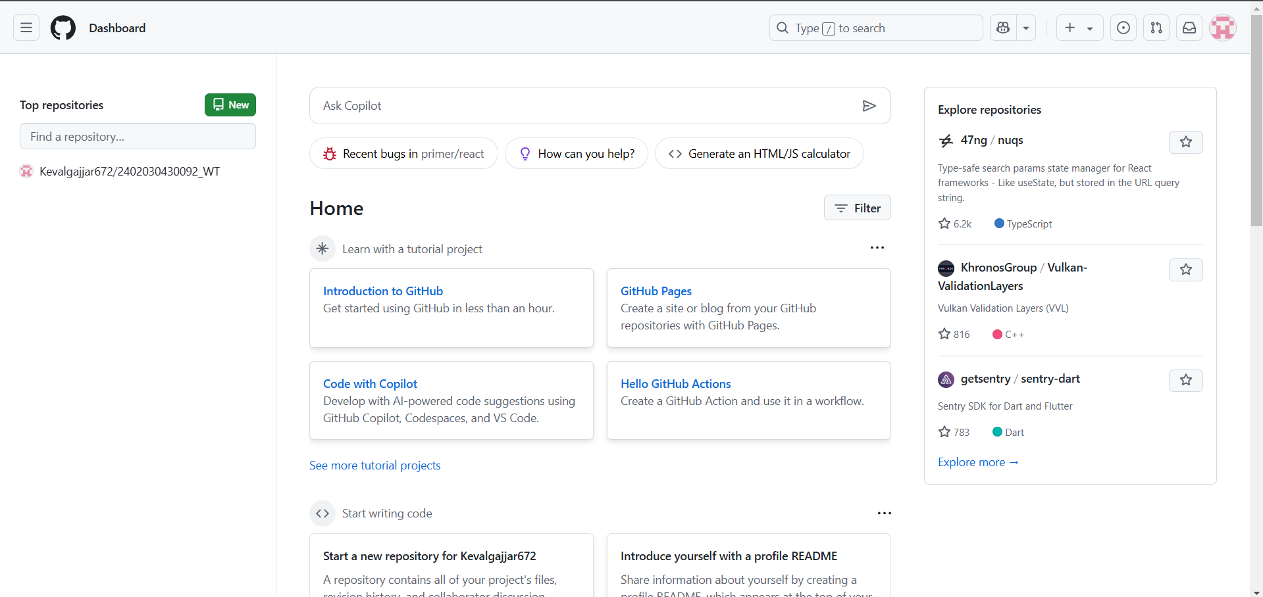

Step 2 - In the Repository name field, enter your enrollment number

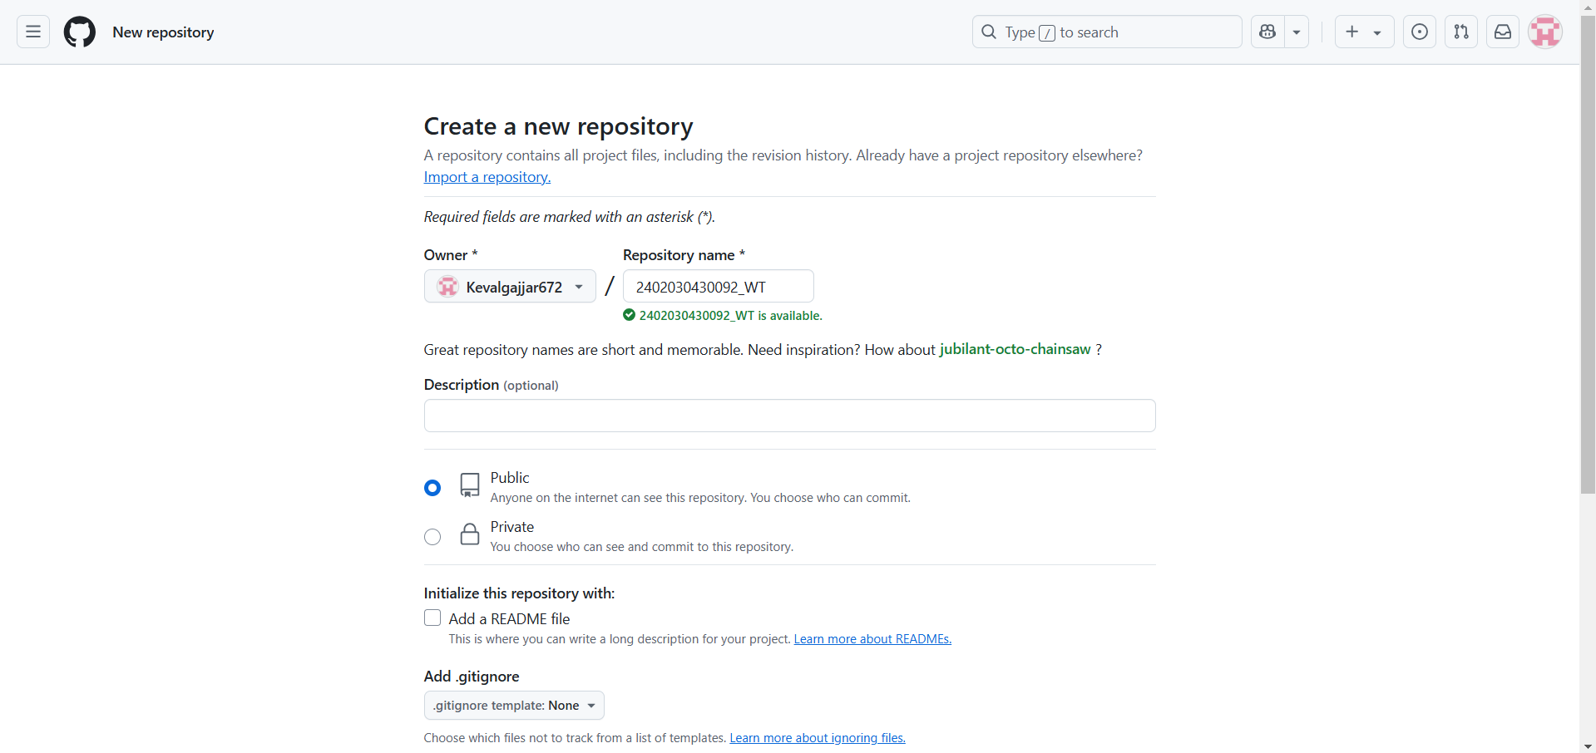

Step 3 - Click "Create repository".

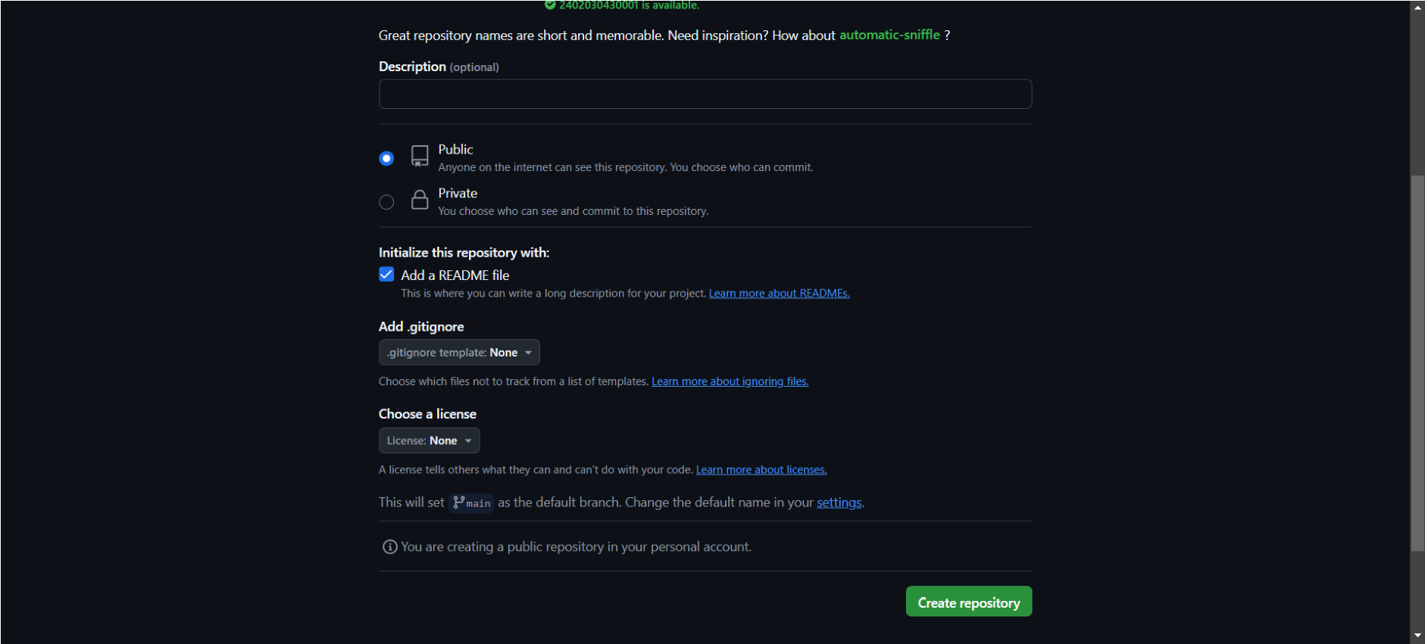

Step 4 - Click the "Add file" dropdown, select "Create new file

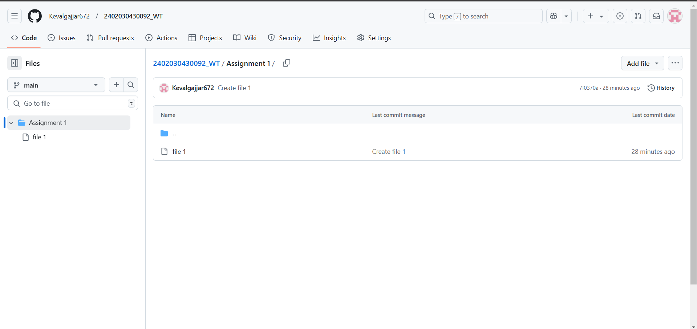

Step 5 - Type the folder name followed by a slash (/) to create the folder structure and click on commit changes.

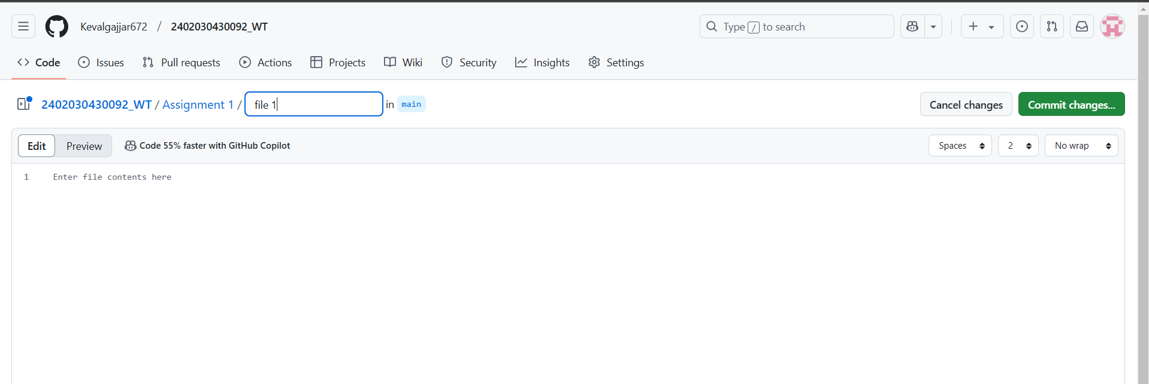

Step 6 – Assignment 1 folder created

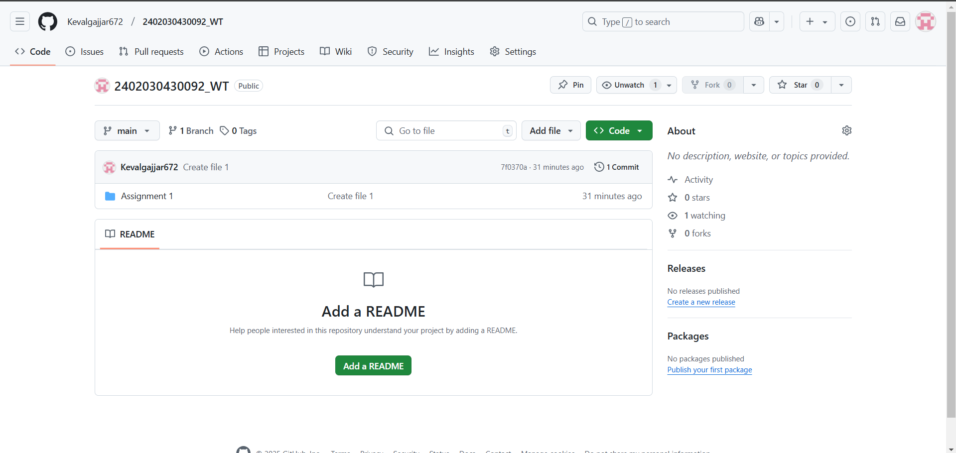

Step 7 – Add the file into the assignment 1 folder

